# Technical Architecture:

Project Design Phase-II Technology Stack (Architecture & Stack)

|  |  |
| --- | --- |
| Date | 03 October 2022 |
| Team ID | PNT2022TMID48980 |
| Project Name | Project - IoT Based Safety Gadget for Child Safety Monitoring and Notification |
| Maximum Marks | 4 Marks |

The Deliverable shall include the architectural diagram as below and the information as per the table1 & table 2

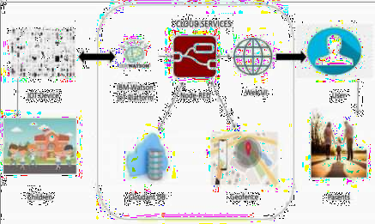

# Table-1 : Components & Technologies:

|  |  |  |  |
| --- | --- | --- | --- |
| **S.No** | **Component** | **Description** | **Technology** |
| 1. | User Interface | User had to register and view the other device’s location. e.g: Web UI, Mobile App etc. | HTML, CSS, JavaScript |
| 2. | IoT Application Logic-1 | Registration of child’s and parent’s device in each  others device | Python |
| 3. | IoT Application Logic-2 | Child’s GPS should be in on condition, Parent’sdevice should always connected to Child’s device | IBM Watson Assistant IBM |
| 4. | IoT Application Logic-3 | If child shouts out of danger it will be notified to parent’s device by tracking & converting using STT Data | Watson STT ServiceSQlite, |
| 5. | Database | Type can be any format such as arbitrary binarydata, text. User-defined blob of data sent from CloudIoT Core to a device etc. | InFluxDB |
| 6. | Cloud Database | Users install tracking software on a cloud infrastructure to implement the database. | IBM DB2, IBM Cloudant etc. |
| 7. | File Storage | Files will be labeled with what they contain and howlong they should be kept. | IBM Block Storage or Local Filesystem |
| 8. | External API-1 | Purpose of External API used in the device is to usethe internet for communicating and conducting allotted  operations efficiently. | Aadhar API, etc. |
| 9. | External API-2 | External API used in the device to expose data that  enables those devices to transmit data to your device/mobile, acting as a data interface. | City Geo-Location Lookup API etc. |
| 10. | Machine Learning Model | IoT and machine learning deliver insights otherwise hidden in data for rapid, automated responses and improved decision making | Object Recognition Model, Danger Prediction Model etc. |
| 11. | Infrastructure (Server / Cloud) | Application Deployment on Local System / Cloud Local Server Configuration: Wearable tech deviceCloud Server Configuration: Massive network thatsupports  IoT devices and applications | Local, Cloud Foundry, Kubernetes, Underlying Infrastructure etc. |

**Table-2: Application Characteristics:**

|  |  |  |  |
| --- | --- | --- | --- |
| **S.No** | **Characteristics** | **Description** | **Technology** |
| 1. | Open-Source Frameworks | Device that removes much of the manual work needed to write and configure code. It provides rapid development, is easy to set up and has a strong support base | Main flux, Thinger.io, Zetta for non-stop streaming of child Condition, Open-remote |
| 2. | Security Implementations | To trigger the alarm and enable automatic voice recording whenever the emergency button is pressed. | e.g. SHA-256, Encryption of data regarding child condition, Firewalls, Antivirus, Data Loss Prevention |
| 3. | Scalable Architecture | If problem arises parents can see the features like location, voice recordings of the child along with live tracking around the children without hindrance | Multiple Data Storage Technologies, Reliable Micro services, Automated Bootstrapping |
| 4. | Availability | Child monitor, audio monitor, location monitor | GPS, GSM, microphone, Raspberry pi microprocessor |
| 5. | Performance | When the child crossed the geo-fence, the device starts record the sound and sends it to the parent(user). | GSM tracker, High Durable Device Battery |